Group 1:
Conceptual Design - Entity Relationship Diagram (ERD)

1
M
performs
M
1
performs
1
1
triggers
1
1
triggers
1
1
triggers
QA_Auditor
qa_auditor_id
qa_auditor_name
Vendor
vendor_id
vendor_name
vendor_contact
Business_Owner
business_owner_id
business_owner_name
1
M
oversees
IT_Audit
it_audit_id
it_audit_type
it_physical_audit_schedule_date
it_paper_audit_questionnaire_status
it_audit_summary_status
it_audit_missing_docs

IT_Owner
it_owner_id
it_owner_name
QA_Audit
qa_audit_id
qa_audit_status
qa_audit_missing_docs
Cyber_Security Assessment
cyber_security_assessment_id
cyber_security_assessment_type
rsi_score
dbi_score
cyber_security_remediation_status

Audit
audit_id
audit_start_date
audit_completion_date
audit_status
audit_category
comments_findings
1
1
is associated with

Logical Design - Bachman Diagram

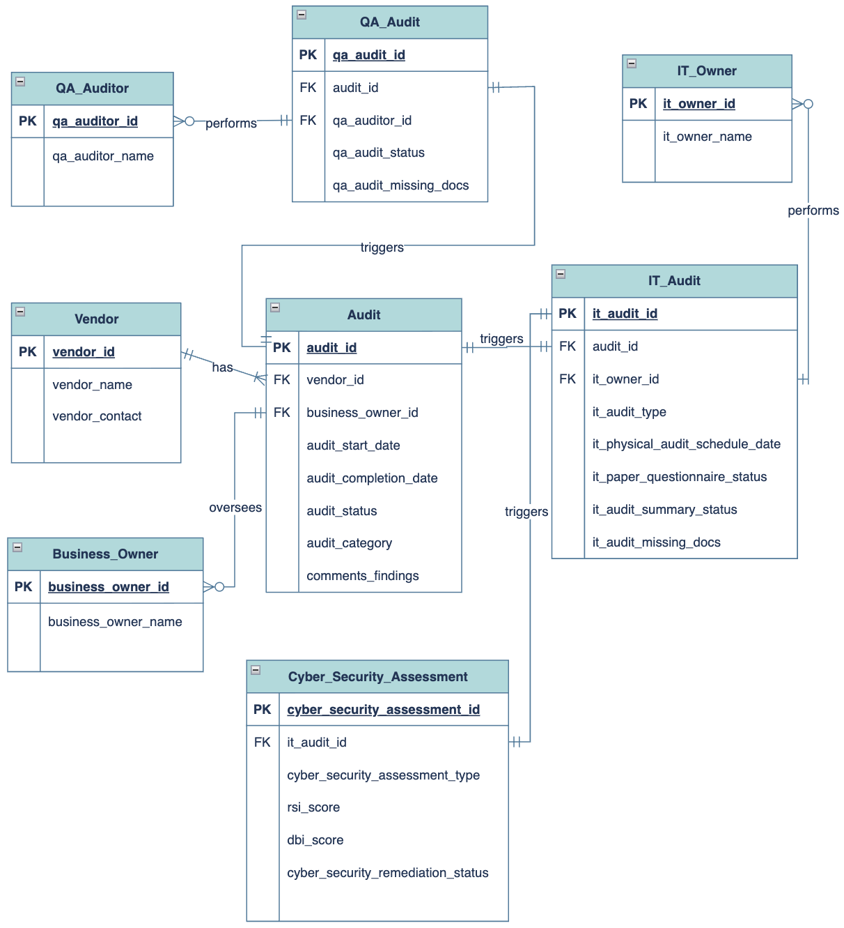

Bachman Diagram (Relations)
VENDOR(vendor_id, vendor_name, vendor_contact)
AUDIT(audit_id, vendor_id, business_owner_id, audit_start_date, audit_completion_date, audit_status, audit_category, comments_findings)
BUSINESS_OWNER(business_owner_id, business_owner_name)
QA_AUDIT(qa_audit_id, audit_id, qa_auditor_id, qa_audit_status, qa_audit_missing_docs)
IT_AUDIT(it_audit_id, audit_id, it_owner_id, it_audit_type, it_physical_audit_schedule_date, it_paper_audit_questionnaire_status, it_audit_summary_status, it_audit_missing_docs)
CYBER_SECURITY_ASSESSMENT(cyber_security_assessment_id, it_audit_id, cyber_security_assessment_type, rsi_score, dbi_score, cyber_security_remediation_status)
IT_OWNER(it_owner_id, it_owner_name)

Data Dictionary:
Attribute | Data Type | Description
vendor_id | INT | Unique identifier for a vendor.
vendor_name | VARCHAR(100) | Name of the vendor.
vendor_contact | VARCHAR(150) | Vendor contact information.
business_owner_id | INT | Unique identifier for a Business Owner.
business_owner_name | VARCHAR(100) | Name of the Business Owner.
audit_id | INT | Unique identifier for the overall vendor audit.
audit_start_date | DATE | Date the overall audit begins.
audit_completion_date | DATE | Date the overall audit is completed; NULL while the audit is in progress.
audit_status | VARCHAR(20) | Overall status of the audit.
audit_category | VARCHAR(50) | Category or classification of the audit.
comments_findings | TEXT | Overall audit comments and findings.
qa_auditor_id | INT | Unique identifier for a QA Auditor.
qa_auditor_name | VARCHAR(100) | Name of the QA Auditor.
qa_audit_id | INT | Unique identifier for the QA Audit.
qa_audit_status | VARCHAR(20) | Current status of the QA Audit.
qa_audit_missing_docs | TEXT | Missing documents identified during the QA Audit.
it_owner_id | INT | Unique identifier for an IT Owner.
it_owner_name | VARCHAR(100) | Name of the IT Owner.
it_audit_id | INT | Unique identifier for the IT Audit.
it_audit_type | VARCHAR(20) | Type of IT Audit, such as remote or paper.
it_physical_audit_schedule_date | DATE | Scheduled date for the IT physical Audit when  Applicable; NULL if not applicable
it_paper_audit_questionnaire_status | VARCHAR(30) | Status of the paper questionnaire process when applicable.
it_audit_summary_status | VARCHAR(30) | Status of the final IT Audit summary.
it_audit_missing_docs | TEXT | Missing documents identified during the IT Audit.
cyber_security_assessment_id | INT | Unique identifier for the Cyber Security Assessment.
cyber_security_assessment_type | VARCHAR(50) | Type or category of Cyber Security Assessment.
rsi_score | DECIMAL(5,2) | RSI score obtained from Black Kite.
dbi_score | DECIMAL(5,2) | DBI score obtained from Black Kite.
cyber_security_remediation_status | VARCHAR(30) | Indicates whether Cyber Security remediation is required, not required, or completed.

